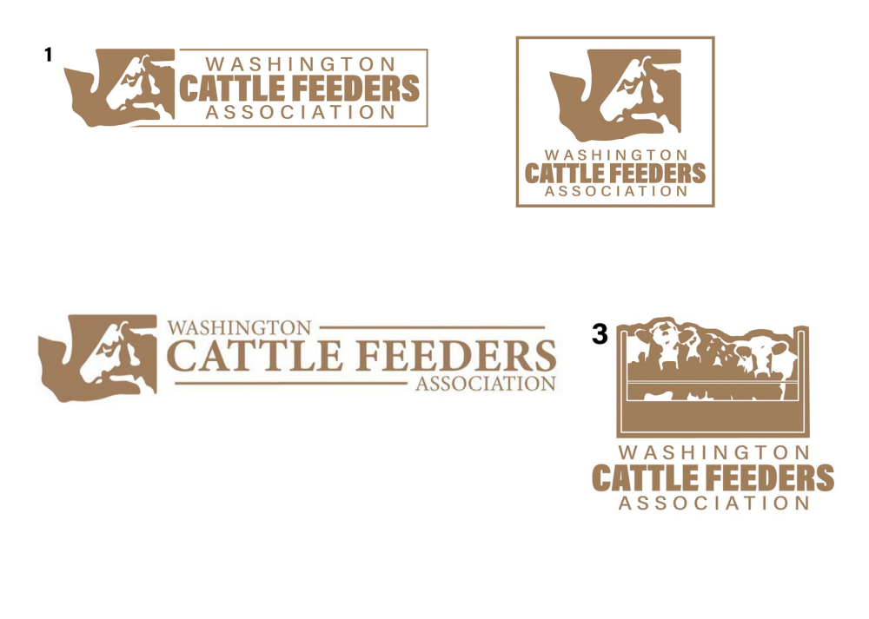

2021 ANNUAL
GOLF TOURNAMENT & DINNER
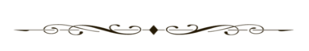

CANYON LAKES GOLF COURSE
KENNEWICK, WA
Thursday, July 15, 2021

Registration 11:30am Shotgun Start 1:00pm
Dinner immediately after Golf - 5:30pm
4 Person Scramble
Each entry includes golf, cart, range balls & DINNER!

ALL PROCEEDS GO TO SCHOLARSHIP FUND
Entry Fees:
Reserve by July 6 After July 6
Team of 4 - $375 Team of 4 - $385
Individual - $95 Individual - $100
Dinner Only - $30 Dinner Only - $35

TEAM INFORMATION

Player Name Phone/Email
_____________________________________________________________
_____________________________________________________________
_____________________________________________________________
_____________________________________________________________

Dinner only guests:
____________________________________ ____________________________________
____________________________________
____________________________________

TOTAL AMOUNT PAID:________ Check Enclosed___________ Credit Card:_______________________

Name on Credit Card:________________________________
Card#_____________________________________________
Exp. Date:_____________________________ Billing Zip Code___________________

Make checks payable to WCFA. Return all entry forms and fees to: WCFA, PO Box 10831, Yakima, WA 98909 or email jack@wafeeders.org For more information call Jack 509-929-1711

