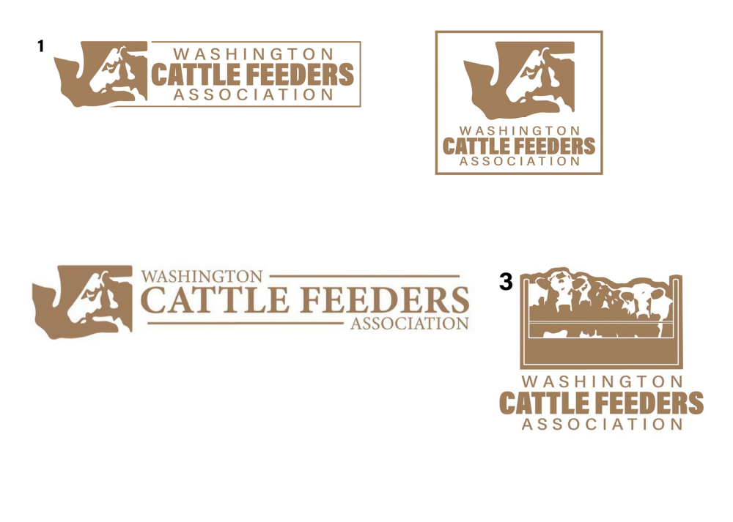

2021 ANNUAL
GOLF TOURNAMENT & DINNER

CANYON LAKES GOLF COURSE
KENNEWICK, WA
Thursday, July 15, 2021

TOURNAMENT SPONSORSHIP

HOLE SPONSOR: $100.00

Sponsor signs will be on the golf course, and the rules sheet that goes to every player.

CONTEST HOLE SPONSOR: $100.00
KP’S, LONG DRIVE HOLES
Sponsor information announced during awards ceremony at dinner.

MAJOR SPONSORSHIP: $500.00
Sponsor information announced during awards ceremony at dinner, banner displayed all day.

Want to sponsor or donate items for Tee Prizes or Gifts for Golfers?
Email jack@wafeeders.org

Company Name, Address, Phone Number/email

______________________________________________________________________
______________________________________________________________________

TOTAL AMOUNT PAID:________ Check Enclosed______ Credit Card:_____

Name on Credit Card:_________________________ Card#___________________________________

Exp. Date:_____________________________ Billing Zip Code___________________

Make checks payable to WCFA.
Return form and fee to: WCFA PO Box 10831, Yakima, WA 98909
email jack@wafeeders.org
For more information call 509-929-1711

