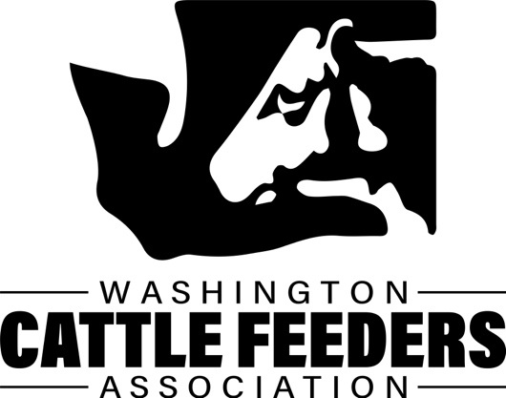
WASHINGTON CATTLE FEEDERS ASSOCIATION SCHOLARSHIP APPLICATION 2023
Application must be word processed. No hand written applications will be accepted.
Name:
Phone:
Age:
Sex:
Mailing Address:
Email Address:
Parent or Guardian’s Names:
High School Attended:
Graduation Date:
High School Grade Point (must have a 3.0 GAP or better):

College Grade Point: (if applicable must have a 3.0 GAP or better)

College will Attend or Attending now:
College Major:
Date of College Graduation: (Known or anticipated)
High School/College Activities:
Summarize your experience with cattle feedlots, livestock and/or agriculture:
What are your future goals and how will this scholarship help you achieve them?
Any other comments that you would like to add?
Please include:
- A Resume showing your in-school and out-of-school activities, any awards or honors you have received, and any work experience during high school or college.

- Transcript

- Three letters of Recommendation

The application form and accompanying information must be returned to:
Washington Cattle Feeders Association
P.0. Box 10831
Yakima, WA, 98909
jack@wafeeders.org

APPLICATION DEADLINE: April 15, 2023;
late applications will not be accepted.

